**Act Report**

WeRateDogs is a twitter account that rates people’s dogs with a  humorous comment about the dog. It was started in 2015 by college student Matt Nelson, and has received international media coverage both for its popularity and for the attention drawn to social media copyright law when it was suspended by Twitter.

It receives dog pictures, posts, comments them, and provide a rating to dogs. These ratings are on a denominator of 10. The ratings are generally high.

As part of the Data Scientist Foundation program, I was asked to analyse the data of a twitter handler name “WeRateDogs”. This archive contains tweet data for 5000+ tweets as on 1st August 2017.

This work is a project part of the Udacity Data Analyst Nanodegree program, the goal was the creation of a master dataset using three main source ( a file that was handed out, a file hosted on Udacity servers and data gathered using the twitter API based on tweet IDs.

Most of the work concentrates on creating a useable, clean dataset that will be the basis for drawing accurate insights and conclusions.

**Dogs that generated likes most:**

First thing I did is plotting a bar chart of favorite counts of dog breeds.

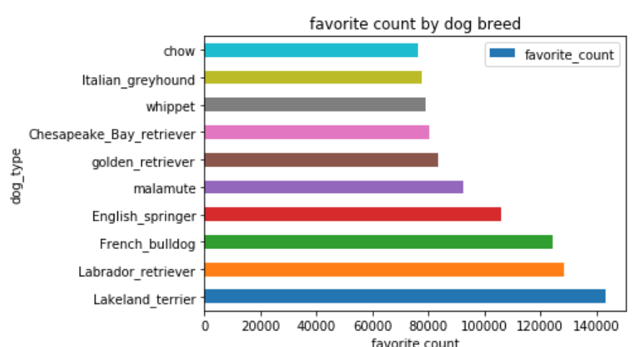

The Labrador retriever has the highest number of likes (Lakeland terrier has a low level confidence interval so it as excluded), followed by the French Bulldog

**Dogs that generated likes most:**

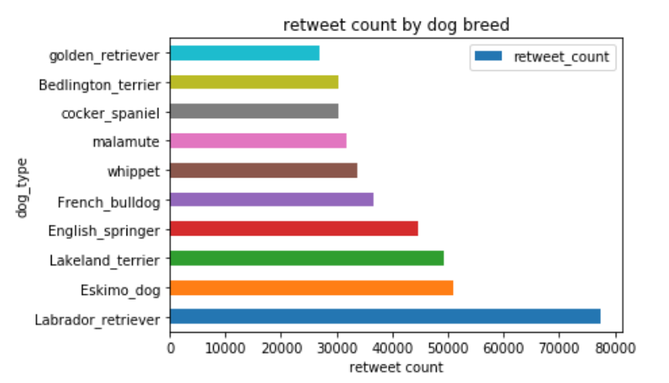

Second bar charts of retweets shows again the popularity of the Labrador retriever, which was an expected result, which leads to suspect a possible correlation between the number of retweets and favorites each breed of dog, receives.

Next we are going to investigate that.

**Correlation between retweets and favorite counts**

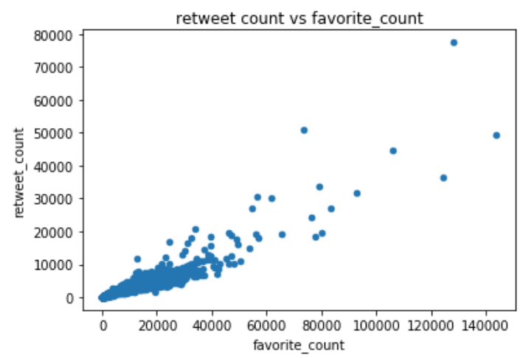

The scatter plot reveals an obvious correlation between the retweets and favorites, which confirms our suspicions.

Next, we are going to investigate the last metric of breeds popularity which is the rating

**Correlation between retweets and rating**

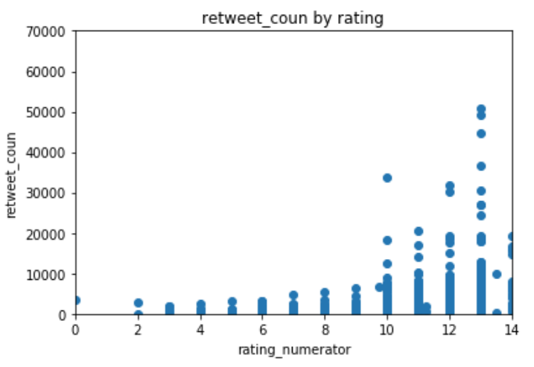

We note also that the retweets and rating are indeed correlated as we can see from the graph. In addition, since favorites and retweets are also correlated, we deduce the same thing for favorite counts and rating.